

Lab 02

**Basic I/O, Variables, Data Types, and Operators**

**Muhammad Mujtaba**

**CMD ID: 540040**

[mmujtaba.bese25seecs@seecs.edu.pk](mailto:mmujtaba.bese25seecs@seecs.edu.pk)

**Class:** BESE 16B

**Batch:** 2k25

## Task 1 [CLO 1]:

### CODE:

#include <iostream>

#include <conio.h>

int main()

{

// storing a constant for 8 stars `*`

const char* STARS = "********";

// printing the required pattern

std::cout << STARS << "\t" << STARS << "\t" << STARS << "\t" << STARS << "\n";

std::cout << "\t" << STARS << "\t" << STARS << "\t" << STARS << "\t" << STARS << "\n";

std::cout << STARS << "\t" << STARS << "\t" << STARS << "\t" << STARS << "\n";

// use to pause termination so we can see the output

_getch();

return 0;

}

### OUTPUT:

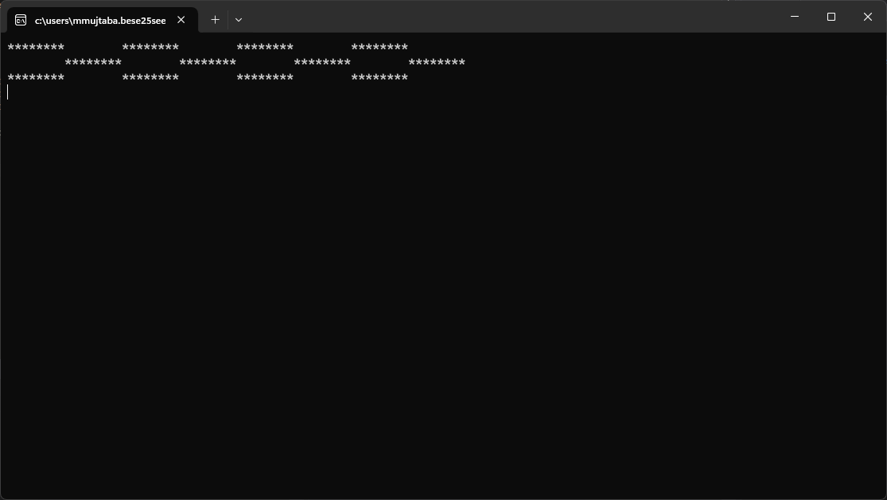

## Task 2 [CLO 1]:

### CODE:

#include <iostream>

#include <conio.h>

// defining helper function to input a function

// var is taken by reference (&) and updated in the function and no value is returned

void getValue(const char* varName, double& var)

{

std::cout << "Enter " << varName << ": ";

std::cin >> var;

// next line will be inserted due to cin

// std::cout << std::endl;

}

int main()

{

// defining variables

double r;

double a;

double b;

double c;

double d;

// getting the values through input

getValue("r", r);

getValue("a", a);

getValue("b", b);

getValue("c", c);

getValue("d", d);

// calculating expression

double answer = 4 / (3 * (r + 34)); // bracket is used after `/` to divide `4` by `(3 * (r + 34))` as WHOLE

// in `(3 * (r + 34))` brackets are used around `r + 34` so that `3 * r` is not calculated first

answer -= 9 * (a + b * c);

// here `b * c` is calculated first and then added to a due to operator precedence

answer += (3 + d * (2 + a)) / (a + b*d);

// brackets are used around `/` to remove operator precedence

// on numerator `d * (2 + a)` is calculated first and then added to three

// in denominator `b * d` is calculated first and then added to `a`

std::cout << "Answer: " << answer;

// pausing termination

_getch();

return 0;  
}

### OUTPUT:

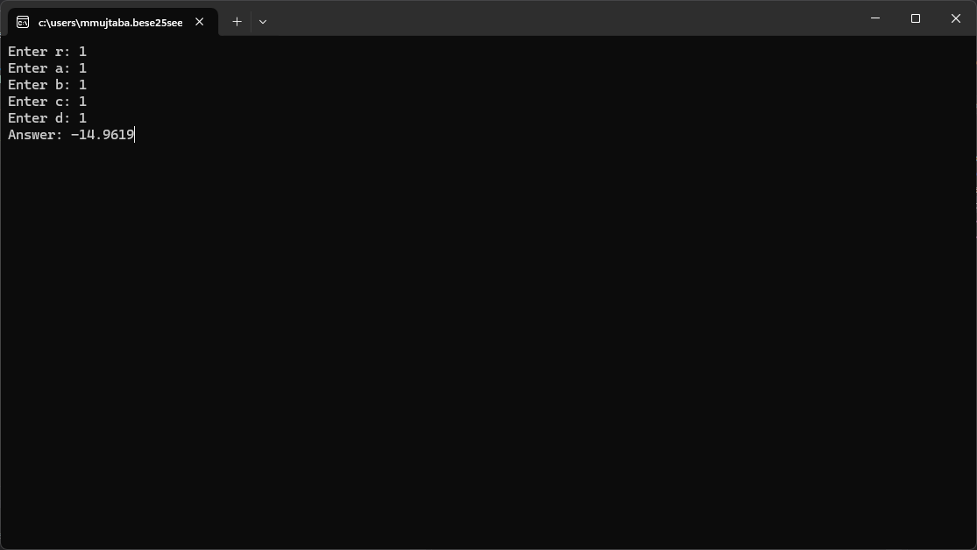

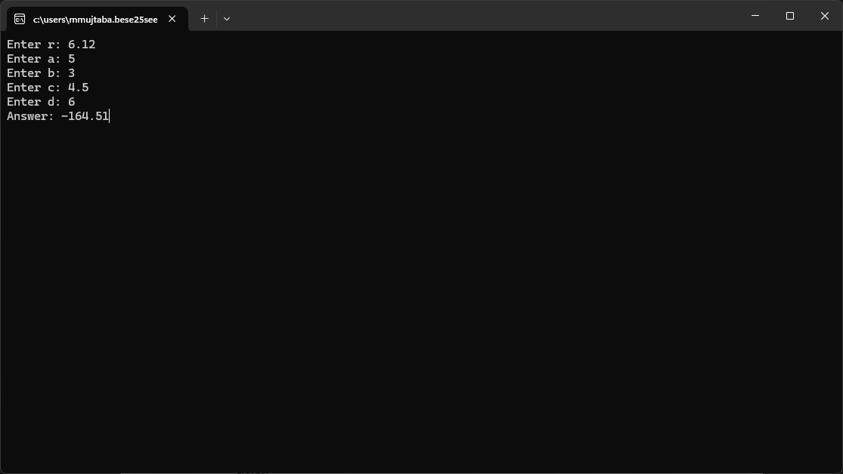

## Task 3 [CLO 3]:

### CODE:

#include <iostream>

#include <conio.h>

#include <string>

// using std::string to return formatted string, returns as 123 KB; 123 MB; 123 bytes

std::string getSizeString(int bytes)

{

// more than 1 KB

if (bytes > 1024)

{

if (bytes > (1024 * 1024)) // 1 MB = 1024 * 1 KB = 1024 * 1024 bytes

return std::to_string(bytes / (1024.0 * 1024.0)) + " MB"; // .0 to invoke implicit conversion

else

return std::to_string(bytes / 1024.0) + " KB";

}

else

return std::to_string(bytes) + " bytes";

}

int main()

{

// declaring variables

int accountNumber;

float transactionAmount;

char accountStatus;

bool activeStatus;

// no initializing needed as memory has already been allocated

// calculating size for one account

const int accountSize_bytes = sizeof(accountNumber) + sizeof(transactionAmount) + sizeof(accountStatus) + sizeof(activeStatus);

int datasetCount = 10000;

// calculating size for 10 000 accounts

const int datasetSize_bytes = accountSize_bytes * datasetCount;

std::cout << "Size of 10000 accounts will be \"" << getSizeString(datasetSize_bytes) << "\" in memory\n\n\n";

_getch();

return 0;

}

### OUTPUT:

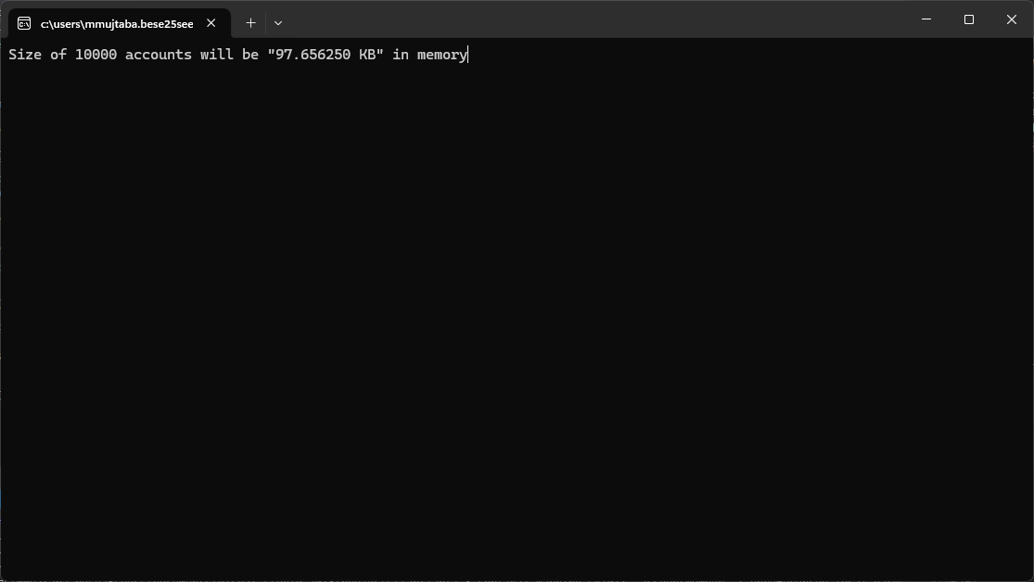

## Task 4 [CLO 3]:

### CODE:

#include <iostream>

#include <bitset>

#include <string>

#include <cstdint>

#include <iomanip>

#include <conio.h>

// defining helper function to input a function

// var is taken by reference (&) and updated in the function and no value is returned

void getValue(const char* varName, uint8_t& outVar)

{

int inputVar;

// using do while loop to make sure user enters number between 0 and 255

// `uint8_t` can only hold values from 0 and 255 inlcusive

do

{

std::cout << "Input value for \"" << varName << "\" between 0 and 255: ";

std::cin >> inputVar;

// stopping the program from going crazy when alphabet is entered

if (std::cin.fail()) // if error is detected in cin

{

std::cin.clear(); // clear error flag

std::cin.ignore(std::numeric_limits<std::streamsize>::max(), '\n'); // discard the input

// ^ says discard all input including newline character

}

} while (inputVar < 0 || inputVar > 255);

outVar = inputVar; // updating var value

// no checks needed as value is confirmed to be between 0 and 255

// next line will be inserted due to cin

// std::cout << std::endl;

}

// inline utility to print

inline void printBits(const std::string& prefix, const uint8_t& val)

{

std::cout << std::left << std::setw(16) << prefix << std::bitset<8>(val) << "\n";

}

int main()

{

// `uint8_t` is an unsigned int with 8 bits

uint8_t firstNum;

uint8_t secondNum;

getValue("A", firstNum);

getValue("B", secondNum);

printBits("BITs A: ", firstNum);

printBits("BITs B: ", secondNum);

printBits("BITs A & B: ", (firstNum & secondNum));

printBits("BITs A | B: ", (firstNum | secondNum));

printBits("BITs A ^ B: ", (firstNum ^ secondNum));

printBits("BITs A << 2: ", (firstNum << 2));

printBits("BITs B >> 3: ", (secondNum >> 3));

_getch();

return 0;

}

### OUTPUT:

